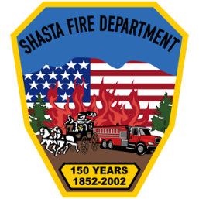
SHASTA FIRE PROTECTION DISTRICT
10644 High St. SHASTA, CA 96087
530-241-4615
www.shastafire.org

Shasta Fire Protection District – Special Board Meeting Agenda

When: Thursday, February 12, 2026 @ 3:00pm

Where: Moore & Bogener Law Office, 1600 West Street, Redding, CA 96001
(As permitted pursuant to Government Code section 54954(b)(7).)

Agenda.
1. Call Meeting to order: 3:00 pm

2. Public Comment on Closed Session Item

3. Closed Session
a. Conference with Legal Counsel- Anticipated Litigation
i. Potential Exposure to Litigation, pursuant to Section 54956(b): One Case.

4. Closed Session Announcement

5. Adjournment

Next regular monthly Meeting is Wednesday, February 18, 2026 at 6:00 pm.

In compliance with the American with Disabilities Act, the Shasta Fire Protection District will make available to any member of the public who has a disability a needed modification or accommodation, including an auxiliary aid or service, in order for that person to participate in the public meeting. A person needing assistance should contact the district office by telephone at (530) 241-4615, or in person or by mail at 10644 High Street, Shasta, CA 96087, or by e-mail at info@shastafire.org, at least 2 working days in advance. Accommodations may include, but are not limited to, interpreters, assistive listening devices, accessible seating, or documentation in an alternate format. If requested, this document and other agenda materials can be made available in an alternative format for persons with a disability who are covered by the Americans with Disabilities Act.

